8. Найти максимальный поток из вершины X1 в вершину X13

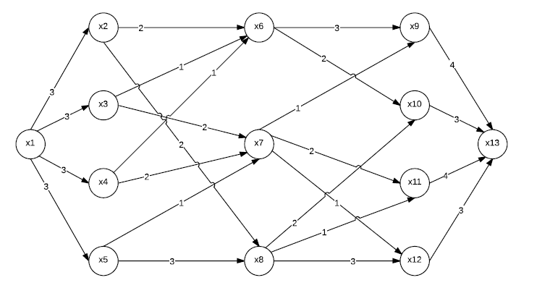

В начале положим для всех дуг (x, y) f(x,y) = 0

Все дуги є I, так как f(x, y) < c(x, y)

(x1, x2) (x2, x6) (x6, x9) (x9, x13)

i(x1, x2) = 3 (x1, x2) є IR

i(x2, x6) = 2 (x2, x6) є R

i(x6, x9) = 3 (x6, x9) є IR

i(x9, x13) = 4 (x9, x13) є IR

min{3, 2, 3, 4} = 2

f(x1, x2) = 0 + 2 = 2

f(x2, x6) = 0 + 2 = 2

f(x6, x9) = 0 + 2 = 2

f(x9, x13) = 0 + 2 = 2



(x1, x3) (x3, x6) (x6, x9) (x9, x13)

i(x1, x3) = 3

i(x3, x6) = 1

i(x6, x9) = 3 – 2 = 1

i(x9, x13) = 4 – 2 = 2

min{3, 1, 1, 2} = 1

f(x1, x3) = 0 + 1 = 1

f(x3, x6) = 0 + 1 = 1

f(x6, x9) = 2 + 1 = 3

f(x9, x13) = 2 + 1 = 3



(x1, x3) (x3, x7) (x7, x9) (x9, x13)

i(x1, x3) = 3 – 1 = 2

i(x3, x7) = 2

i(x7, x9) = 1

i(x9, x13) = 4 – 3 = 1

min{2, 2, 1, 1} = 1

f(x1, x3) = 1 + 1 = 2

f(x3, x7) = 0 + 1 = 1

f(x7, x9) = 0 + 1 = 1

f(x9, x13) = 3 + 1 = 4



(x1, x4) (x4, x6) (x6, x10) (x10, x13)

i(x1, x4) = 3 – 0 = 3

i(x4, x6) = 1 – 0 = 1

i(x6, x10) = 2 – 0 = 2

i(x10, x13) = 3 – 0 = 3

min{3, 1, 2, 3} = 1

f(x1, x4) = 1

f(x4, x6) = 1

f(x6, x10) = 1

f(x10, x13) = 1



(x1, x2) (x2, x8) (x8, x10) (x10, x13)

i(x1, x2) = 3 – 2 = 1

i(x2, x8) = 2 – 0 = 2

i(x8, x10) = 2 – 0 = 2

i(x10, x13) = 3 – 1 = 2

min{1, 2, 2, 2} = 1

f(x1, x2) = 2 + 1 = 3

f(x2, x8) = 0 + 1 = 1

f(x8, x10) = 0 + 1 = 1

f(x10, x13) = 1 + 1 = 2



(x1, x5) (x5, x8) (x8, x10) (x10, x13)

i(x1, x5) = 3

i(x5, x8) = 3

i(x8, x10) = 2 – 1 = 1

i(x10, x13) = 3 – 2 = 1

min{3, 3, 1, 1} = 1

f(x1, x5) = 0 + 1 = 1

f(x5, x8) = 0 + 1 = 1

f(x8, x10) = 1 + 1 = 2

f(x10, x13) = 2 + 1 = 3



(x1, x3) (x3, x7) (x7, x11) (x11, x13)

i(x1, x3) = 3 – 2 = 1

i(x3, x7) = 2 – 1 = 1

i(x7, x11) = 2 – 0 = 2

i(x11, x13) = 4 – 0 = 4

min{1, 1, 2, 4} = 1

f(x1, x3) = 2 + 1 = 3

f(x3, x7) = 1 + 1 = 2

f(x7, x11) = 0 + 1 = 1

f(x11, x13) = 0 + 1 = 1



(x1, x4) (x4, x7) (x7, x11) (x11, x13)

i(x1, x4) = 3 – 1 = 2

i(x4, x7) = 2 – 0 = 2

i(x7, x11) = 2 – 1 = 1

i(x11, x13) = 4 – 1 = 3

min{2, 2, 1, 3} = 1

f(x1, x4) = 1 + 1 = 2

f(x4, x7) = 0 + 1 = 1

f(x7, x11) = 1 + 1 = 2

f(x11, x13) = 1 + 1 = 2



(x1, x5) (x5, x8) (x8, x11) (x11, x13)

i(x1, x5) = 3 – 1 = 2

i(x5, x8) = 3 – 1 = 2

i(x8, x11) = 1 – 0 = 1

i(x11, x13) = 4 – 2 = 2

min{2, 2, 1, 2} = 1

f(x1, x5) = 1 + 1 = 2

f(x5, x8) = 1 + 1 = 2

f(x8, x11) = 0 + 1 = 1

f(x11, x13) = 2 + 1 = 3



(x1, x4) (x4, x7) (x7, x12) (x12, x13)

i(x1, x4) = 3 – 2 = 1

i(x4, x7) = 2 – 1 = 1

i(x7, x12) = 1 – 0 = 1

i(x12, x13) = 3 – 0 = 3

min{1, 1, 1, 3} = 1

f(x1, x4) = 2 + 1 = 3

f(x4, x7) = 1 + 1 = 2

f(x7, x12) = 0 + 1 = 1

f(x12, x13) = 0 + 1 = 1



(x1, x5) (x5, x8) (x8, x12) (x12, x13)

i(x1, x5) = 3 – 2 = 1

i(x5, x8) = 3 – 2 = 1

i(x8, x12) = 3 – 0 = 3

i(x12, x13) = 3 – 1 = 2

min{1, 1, 3, 2} = 1

f(x1, x5) = 3

f(x5, x8) = 3

f(x8, x12) = 1

f(x12, x13) = 2



Увеличивающего пути нет!

Максимальный поток = 2 + 1 + 1 + 1 + 1 + 1 + 1 + 1 + 1 + 1 + 1 = 12